  
**Applied A.I. Solutions**

**Presenting Data Science-driven Solutions**

Date: 18th April 2024

**Final Project Report**

**Fire and Smoke Detection**

**Group – 11**

Members:

Dheeraj Puttapaka (101485432)

Mansi Waman Rajadhyaksha (101498845)

Falgun Khimasiya (101440121)

King Yim Chan (101472281)

**Professor:**

Vejey Gandyer

**Table Of Contents**

1.0 Problem statement 1

2.0 Significance 2

3.0 Literature Review 3

4.0 ML canvas 4

5.0 Model benchmarking 5

6.0 Challenges and issues encountered 6

7.0 CONCLUSIONS 9

8.0 REFERENCEs 10

# Problem statement

Envision a society in which flames are identified immediately, sparing casualties, and reducing destruction. Conventional fire detection systems frequently experience false alarms and are slow. Deep learning, on the other hand, has the potential to completely transform real-time detection while lowering risks and raising safety requirements.

# Significance

Fire and smoke detection projects leveraging YOLOv8 (You Only Look Once) bring several critical advantages to safety and emergency response systems:

1. Early Detection and Rapid Response:

* YOLOv8’s real-time object detection capabilities allow for swift identification of fire and smoke.
* Early alerts enable faster evacuation, firefighting, and risk mitigation.

1. Improved Accuracy and Reliability:

* YOLOv8’s advanced algorithms reduce false positives and enhance detection accuracy.
* Reliable fire and smoke alerts ensure timely action.

1. Adaptability to Diverse Environments:

* YOLOv8 models can be trained on various data sources (e.g., images, video streams, sensor data).
* They adapt seamlessly to different settings, from residential homes to industrial complexes.

1. Scalability and Cost-Effectiveness:

* YOLOv8 scales effortlessly to cover large areas or multiple buildings.
* Cost-effective deployment ensures widespread adoption.

1. Continuous Learning and Improvement:

* YOLOv8 supports transfer learning, allowing models to learn from new data.
* Ongoing improvement ensures robust fire detection over time.

1. Integration with Smart Building Systems:

* YOLOv8 seamlessly integrates into existing smart building infrastructure.
* Centralized monitoring and control enhance overall safety standards.

# literature review

Past available projects

- Various video-based flame and smoke detection algorithms.

- Focus on indoor and outdoor environments

Similar projects

- Detecting flames and smoke in real-time video streams.

- Fusion of visible and thermal images for accurate results.

- Hybrid approaches combining handcrafted features and DL.

Drawbacks

- Handcrafted features

- False positives/Negatives

- Limited Generalization

# ml canvas

The Machine Learning Canvas ensures a holistic approach, addressing technical, ethical, and practical aspects of fire and smoke detection systems. Below shown image gives the idea of our ML canvas created in the initial phase of the project.

# model benchmarking

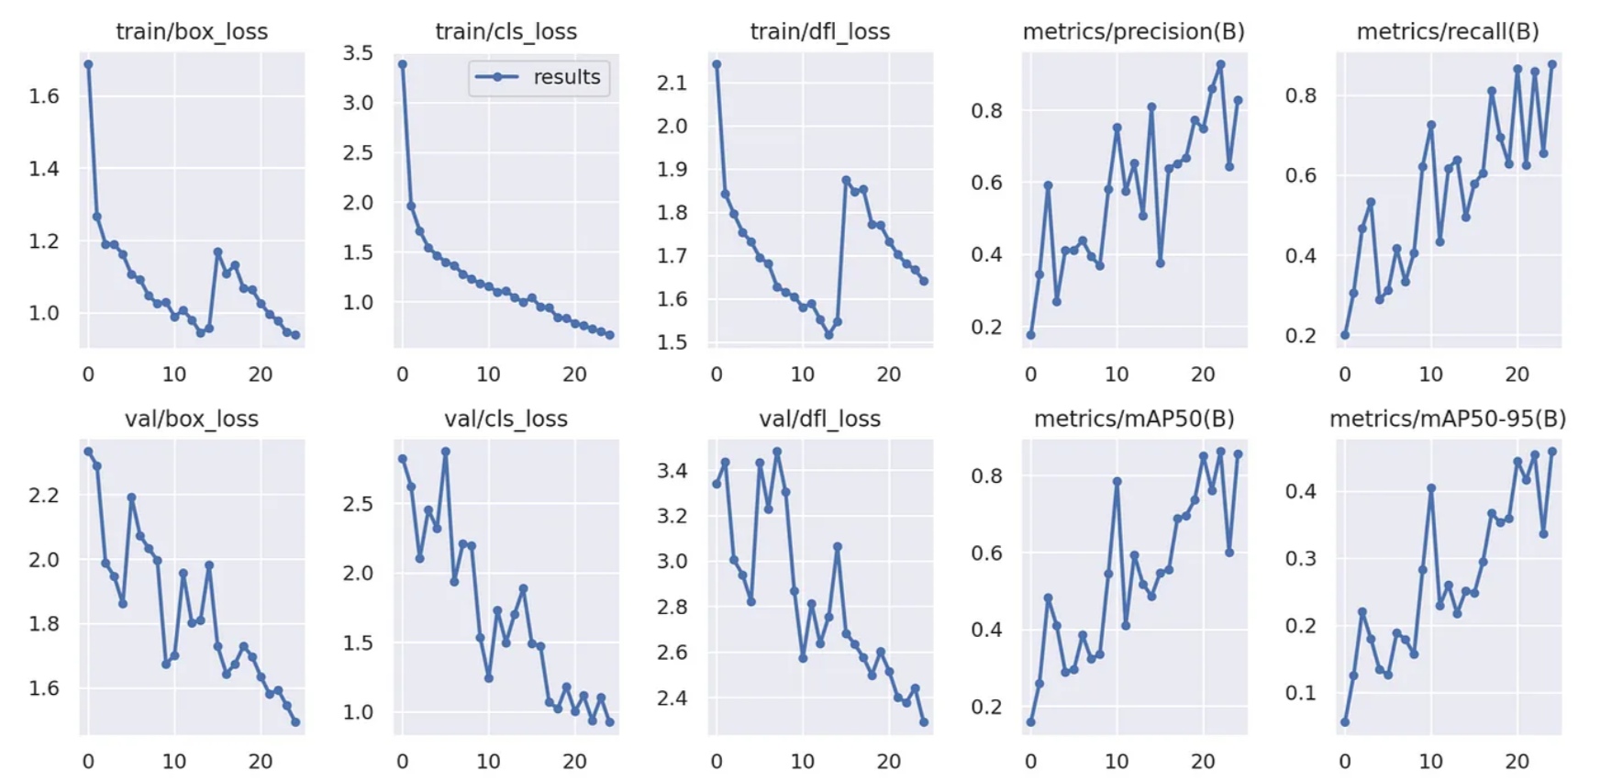

# challenges and issues encountered

1. Ensuring all dependencies (including YOLOv8, Python, and Flask) are properly installed.
2. Ensuring efficient resource utilization (CPU, memory, GPU) and minimizing latency.
3. Balancing performance with cost efficiency.

# conclusion

With the use of customized datasets, YOLOv8 is an effective tool for developing smoke and fire detection systems. It is a potential solution for practical applications that need quick and effective fire and smoke detection because of its speed and precision.

# REFERENCES

1. Avazov K, Mukhiddinov M, Makhmudov F, Cho YI (2022) Fire detection method in smart city environments using a deep-learning-based approach. Electronics 11:73. <https://doi.org/10.3390/electronics11010073>
2. <https://github.com/ultralytics/ultralytics/issues/189>